**Penetration Testing Foscam IP Cameras**

University of Missouri

Daniel Dunn

**Introduction**

The emergence of the Internet of Things and so called IoT devices has spawned panic in the cybersecurity community. Experts define the Internet of Things as a network of physical devices, vehicles, home appliances, and other devices able to connect to the internet. A substantial number of these internet connected smart devices contain major design flaws resulting in serious security breaches ranging from privacy invasion to massive-scale botnets. For example, the Mirai botnet, which targeted insecure IoT devices, successfully attacked and infected over 600,000 devices for use in a Distributed Denial of Service (DDoS) attack.[1] Furthermore, experts predict that up to 30 million IoT devices will be connected to the internet by 2020, resulting in a global market for IoT reaching $7.1 billion.[2,3] As staggering as these numbers are, they represent the target being placed on the Internet of Things and the challenge cybersecurity researchers and professionals face to keep the internet secure.

IP cameras are a category of IoT devices that, if containing security vulnerabilities, could host significant security and privacy implications. One such brand of these cameras is Foscam, a Chinese-based video product manufacturer. The objective of this research project was to penetration test a range of Foscam IP cameras to discover any vulnerabilities and potential exploits. Industry professionals actively conduct research in IP camera security; in particular, F-Secure released a report detailing their own research that resulted in the discovery of several security vulnerabilities in the Foscam C2 and Opticam i5.[4] Building on the findings outlined in the F-Secure report, this research, discussed in the remainder of this report, succeeded in discovering numerous vulnerabilities and attack vectors in the Foscam C2, R2, FI9803P, and FI9831P.

**Selected Devices**

Foscam, an IP camera manufacturer based out of Shenzhen, China, boasts of “distribution channels in more than 30 countries and regions, including Germany, the United States, Britain, Italy, Singapore, India, France and Canada.” Their company website also states that “100 million Foscam products have been sold to over 60 countries.”[5] As such, a range of Foscam IP cameras were selected in an attempt to experience greater differentiation in software and firmware between devices and explore the similarities and differences between any discovered vulnerabilities. The table below lists the selected devices and their firmware versions:

|  |  |  |
| --- | --- | --- |
| **Model Name** | **System Firmware Version** | **Application Firmware Version** |
| Foscam C2 | 1.11.1.8 | 2.72.1.32 |
| Foscam R2 | 1.11.1.8 | 2.71.1.39 |
| Foscam FI9803P | 1.9.3.17 | 2.54.2.37 |
| Foscam FI9831P | 1.5.3.19 | 2.21.2.27 |

**Discovered Vulnerabilities**

Seven vulnerabilities and weaknesses, ranging in severity from the release of sensitive information all the way to the possibility of an attacker being able to gain full control of the device, were discovered during this research. Additionally, every camera tested contained at least five out of the seven vulnerabilities. These findings are detailed below.

**I. Insecure Factory Default Credentials**

Foscam released these cameras from the factory with default credentials of admin:<blank> for the username and password respectively. As the name suggests, this is an administrator account with full access to and control of the camera. Furthermore, the devices do not require a new account to be created to remove the admin account or a password to be set for the account when the user configures the devices. Not until the user attempts to login to the cameras with the web application or mobile application are they prompted to create a new account; this process also disables the admin account as well. However, the devices do not initiate this activity automatically and if the user instead opts to utilize an ONVIF (Open Network Video Interface Forum) application or RTSP-capable (Real Time Streaming Protocol) media player then they may never need to login to the web or mobile application. This thereby leaves the insecure administrator account intact for any malicious actor to exploit.

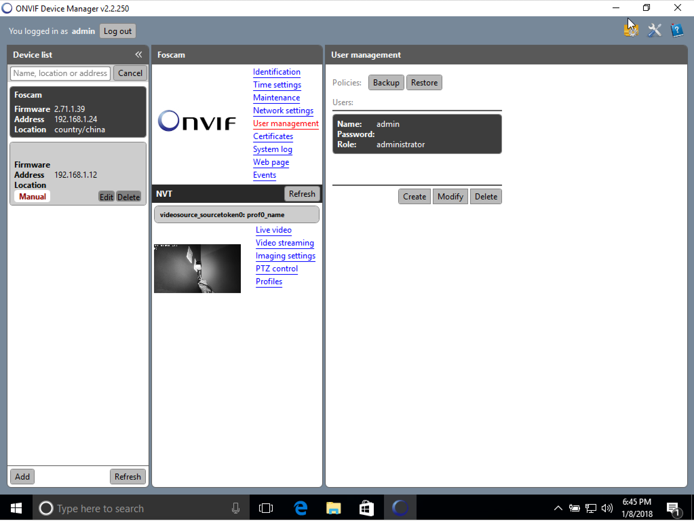

**II. Firewall Limitations**

Investigation reveals that the standard firewall, enabled in the web application, implements limited defensive measures. In fact, it acts only as an IP filter for the web application on ports 88 and 443. By extension, it does not perform any other defensive actions, nor does it block IP addresses from accessing any other ports, such as ONVIF (888), FTP (50021), or RTSP (65534). This means that even if a network administrator identifies and attempts to block a potential threat using the device’s firewall, an attacker can still communicate with the device through other ports and protocols.

**III. Web Application Does Not Require HTTPS**

The standard web application provided with these models is accessible through two ports: 88 and 443. While port 443 forces the use of HTTPS and TLS for secure, encrypted communication (albeit with a certificate error), navigating to port 88 does not require HTTPS or TLS. While the application may use some alternate form of encryption or obfuscation for the password, it sends the username in plaintext. Regardless, it remains unwise to refrain from requiring HTTPS and TLS on all web pages which send sensitive data.

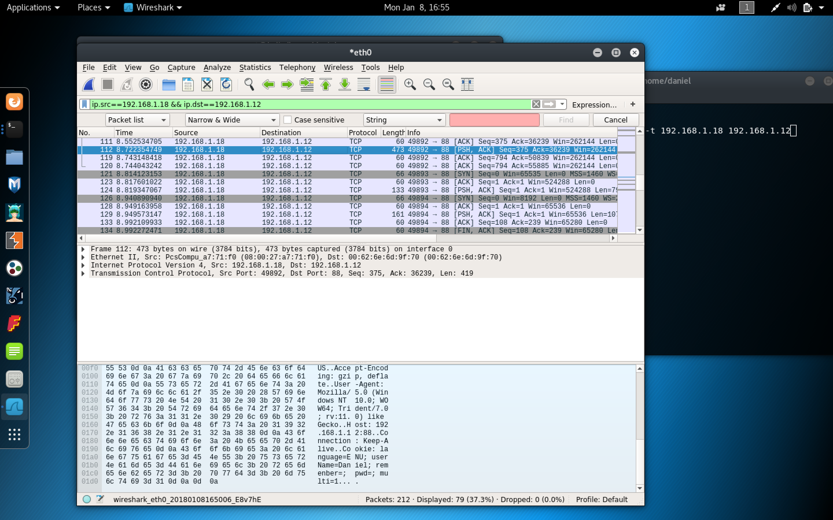

**IV. Device Does Not Limit Number of Login Attempts**

None of the services identified on these devices enforce any form of limit on the number of login attempts, whether from an IP address or on a particular account. This includes the web application, ONVIF, and RTSP on all models, as well as FTP on the C2, R2, and FI9831P models. This behavior allows for an attacker to launch a brute force or dictionary attack against a camera to obtain valid credentials and a foothold on the device.

**V. ONVIF Protocol Transmits Unencrypted Credentials**

The ONVIF protocol, supported by all the devices selected for this study, does not inherently require credentials to be transmitted in an encrypted manner. As a result, while operating an ONVIF application, ONVIF Device Manager[6], credentials are sent in plaintext, and thus may be intercepted and read by an eavesdropper on the network.

**VI. FTP Protocol Transmits Unencrypted Credentials and Data**

Similar to the ONVIF vulnerability that sends unencrypted credentials over the network, these devices send FTP credentials and data in unencrypted packets as well. This vulnerability exists due to the devices leveraging an FTP service rather than SFTP, which encrypts all transmissions. While the FI9803P does not have functional FTP capabilities and therefore does not possess this weakness, the other models all contain this vulnerability.

**Note:** This vulnerability was found in the C2, R2, and FI9831P models.

**VII. ONVIF Reveals Maintenance and Configuration Information**

Some devices leak information through the ONVIF protocol, including potentially sensitive maintenance and configuration data. A user can ‘login’ to the device using the admin:<blank> credentials discussed in the first vulnerability, even if the account has been removed through the web application. The leaked information includes, but is not limited to, the camera name, location, manufacturer, model, system firmware version, application firmware version, MAC address, ONVIF version, DHCP settings, DNS settings, and more. An attacker could utilize this information leak during their reconnaissance phase to discover a trove of valuable, sensitive information.

**Note:** This vulnerability was found in the C2, R2, and FI9831P models.

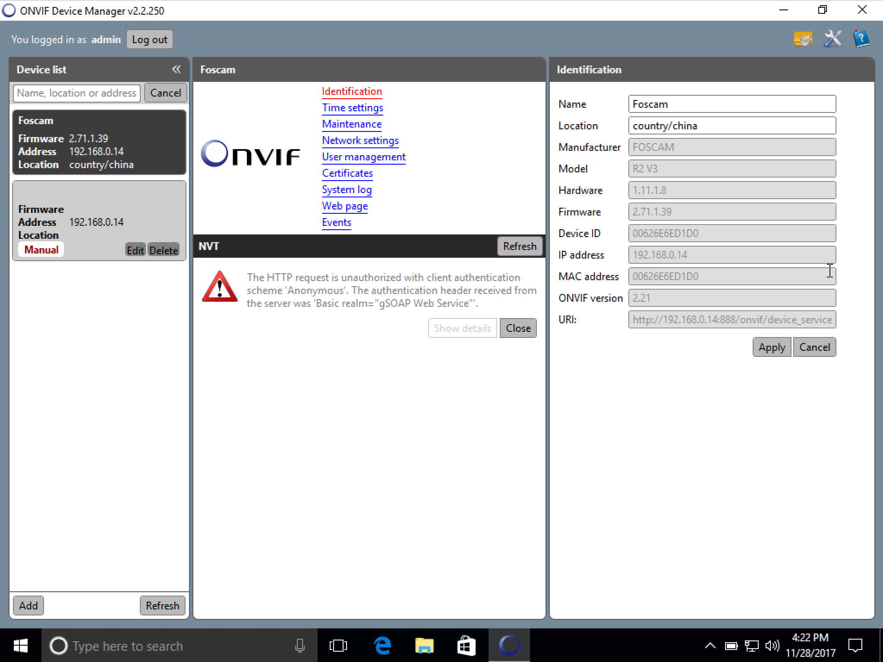

**Potential Attack Vectors**

This section presents a sample of several potential attack vectors that could be carried out by a malicious actor. The attack vectors are split into two general categories: not configured and configured, indicating whether the admin:<blank> account detailed in part I of the Discovered Vulnerabilities section remains active on the device. The primary tools utilized in these attacks are VirtualBox[7] to host Kali Linux[8] and Windows 10[9], Nmap[10], Wireshark[11], VLC Media Player[12], and ONVIF Device Manager[6].

**Not Configured**

*i. View the live RTSP video feed*

These devices allow a user to view the live camera stream by using the RTSP protocol. If an attacker’s goal involves gathering physical intelligence about a location or user for some other nefarious purpose, the attacker can easily exploit the admin:<blank> account to view the live video feed using commercial media software capable of viewing a network stream.

*ii. Utilize FTP server*

An attacker can use the admin:<blank> account to login to the FTP service on these cameras allowing them to upload and download any files of their choosing. Furthermore, the F-Secure report[4] states that this behavior allows an attacker to enable a hidden telnet service that would allow them to upload their own payload for covert, persistent access to the device. Furthermore, this allows an attacker not only access to the device itself, but also the ability to pivot to the rest of the network.

*iii. Create administrator-level user in ONVIF*

An attacker can login to the ONVIF management console, giving them full control of the device, by again using the admin:<blank> credentials that the cameras are shipped with. Account creation is one action, among a multitude of others, that could be taken. An attacker could simply add their own administrator-level account and retain full access to and control of the device, even if the owner of the camera proceeds to configure the device and remove the admin:<blank> account. This control includes the ability to manipulate accounts, modify maintenance information, view the live video feed, operate the PTZ (Pan, Tilt, Zoom) functionality if present, and more.

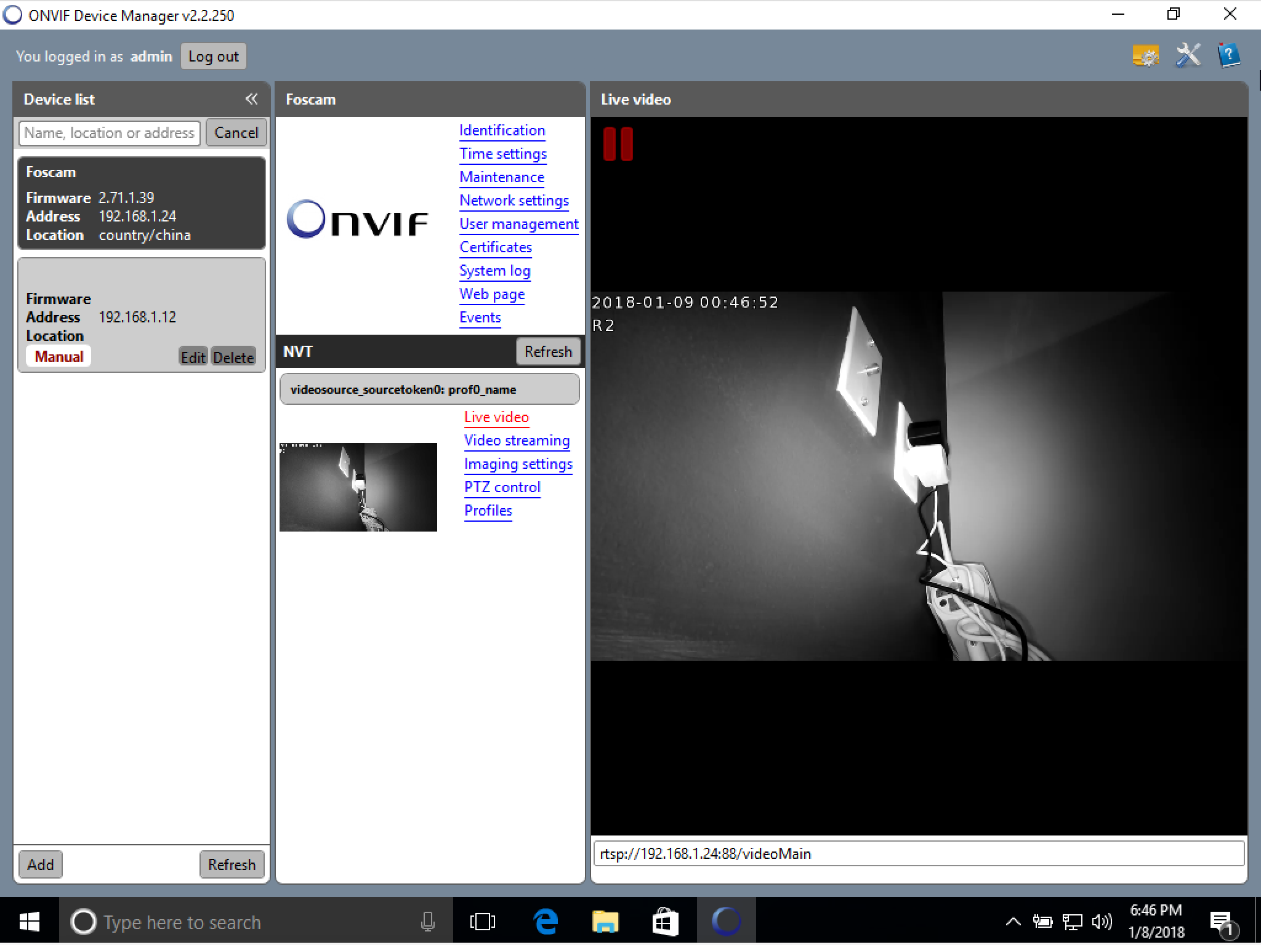

**Configured**

*i. Execute a Man-in-the-Middle attack against ONVIF*

As discussed in part V of the Discovered Vulnerabilities section, the ONVIF protocol does not require credentials to be encrypted before transmission. An attacker can intercept communication between a legitimate user and their device by performing arp-cache poisoning. During the authentication process, the user’s ONVIF application may send the credentials in plaintext, allowing an attacker intercepting these packets to analyze them using Wireshark and quickly uncover the user’s credentials.

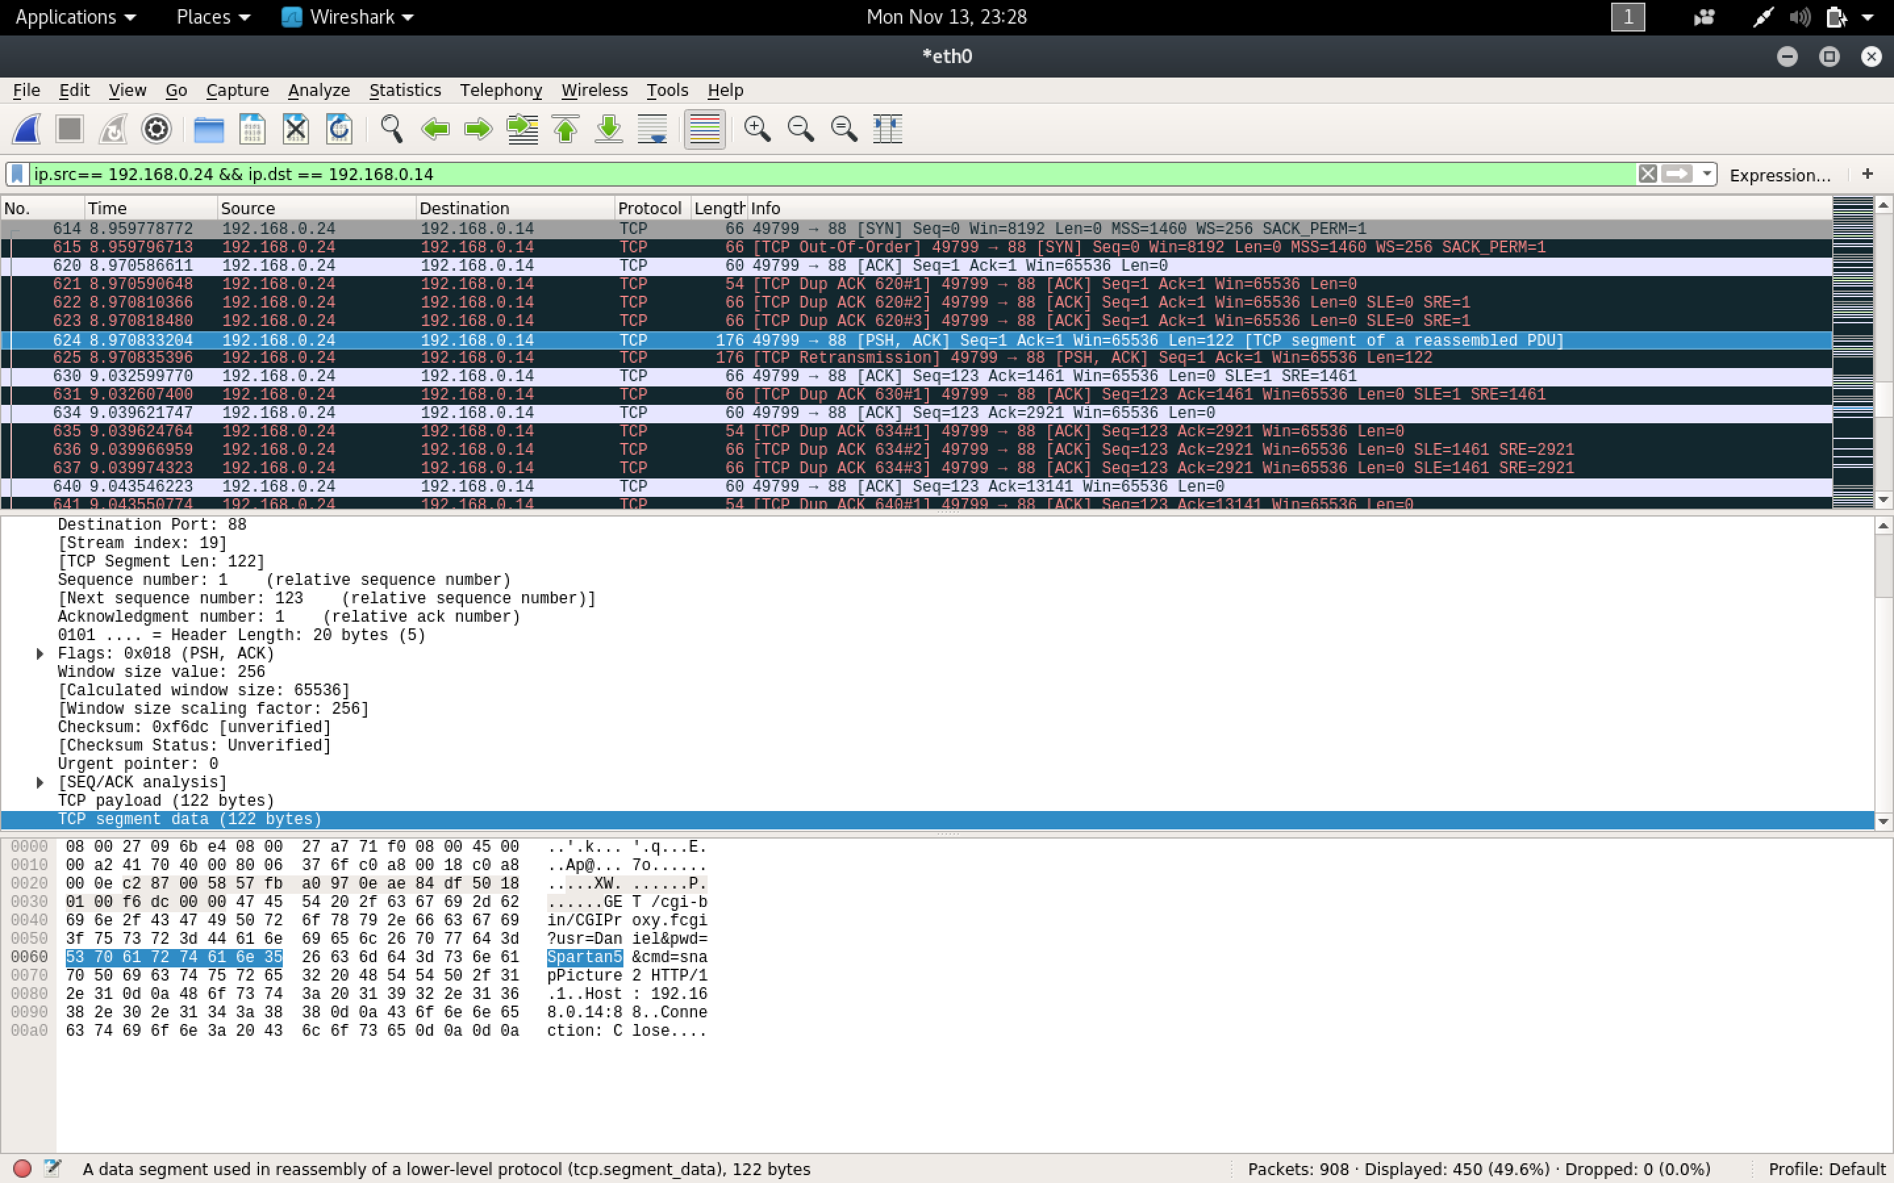

*ii. Execute a Man-in-the-Middle attack against FTP*

Vulnerability VI in the Discovered Vulnerabilities section outlines how the FTP server also sends and receives credentials over the network in plaintext, similar to the ONVIF protocol. Moreover, it sends data and other potentially sensitive information in such a manner as well. This allows an attacker to launch a man-in-the-middle attack, virtually positioning themselves between the camera and an unsuspecting user by employing arp-cache poisoning. Then, the attacker can analyze intercepted packets in Wireshark to discover not only the user’s login information, but also the user’s commands and the camera’s response codes.

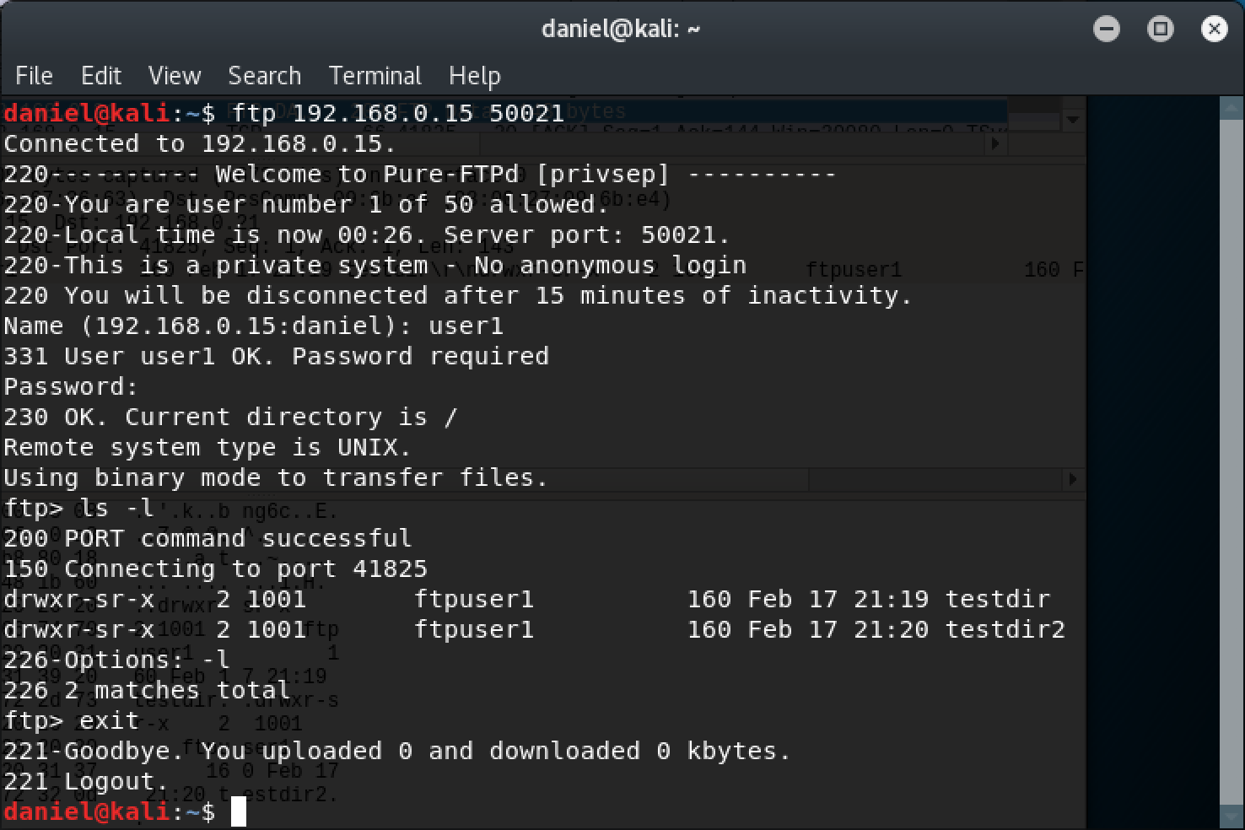

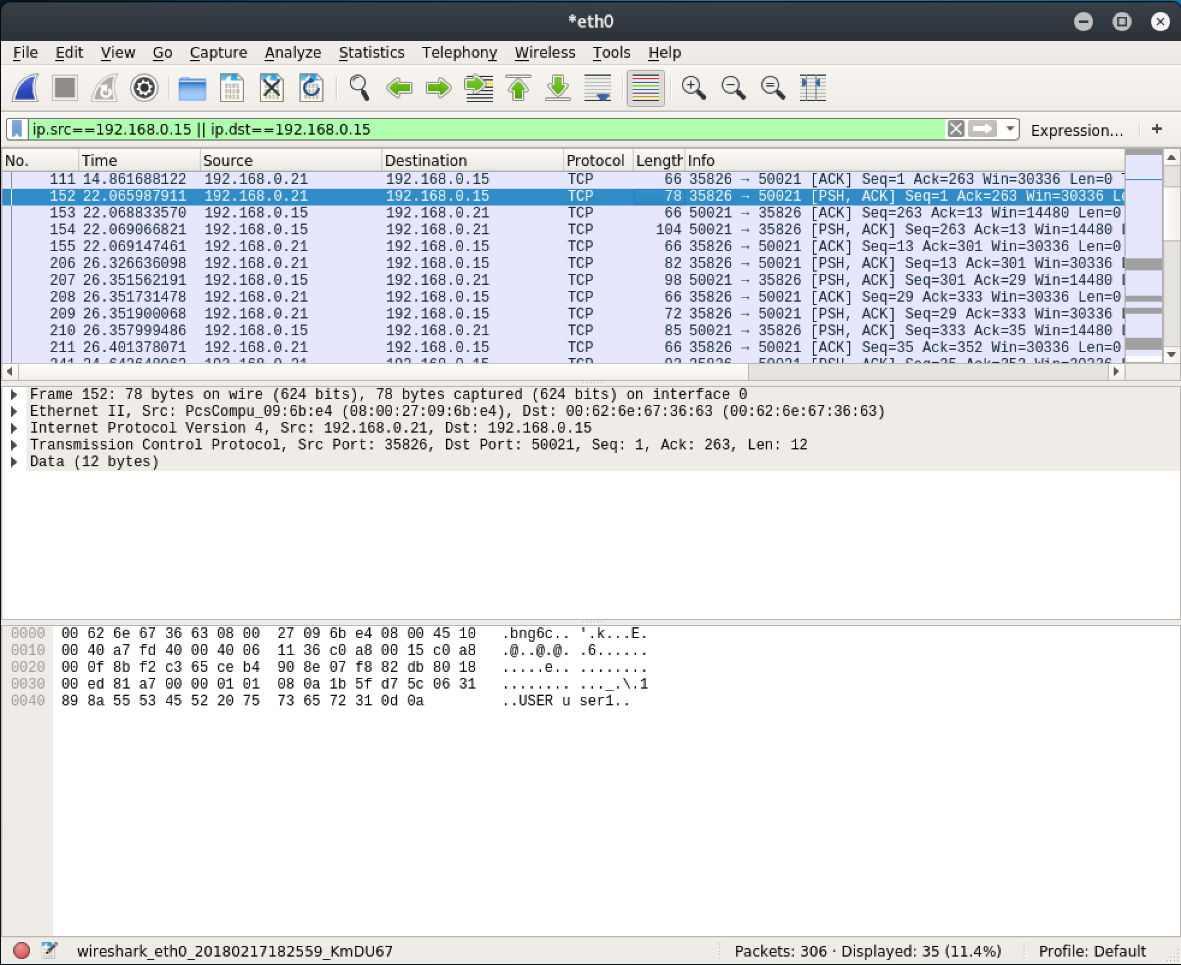

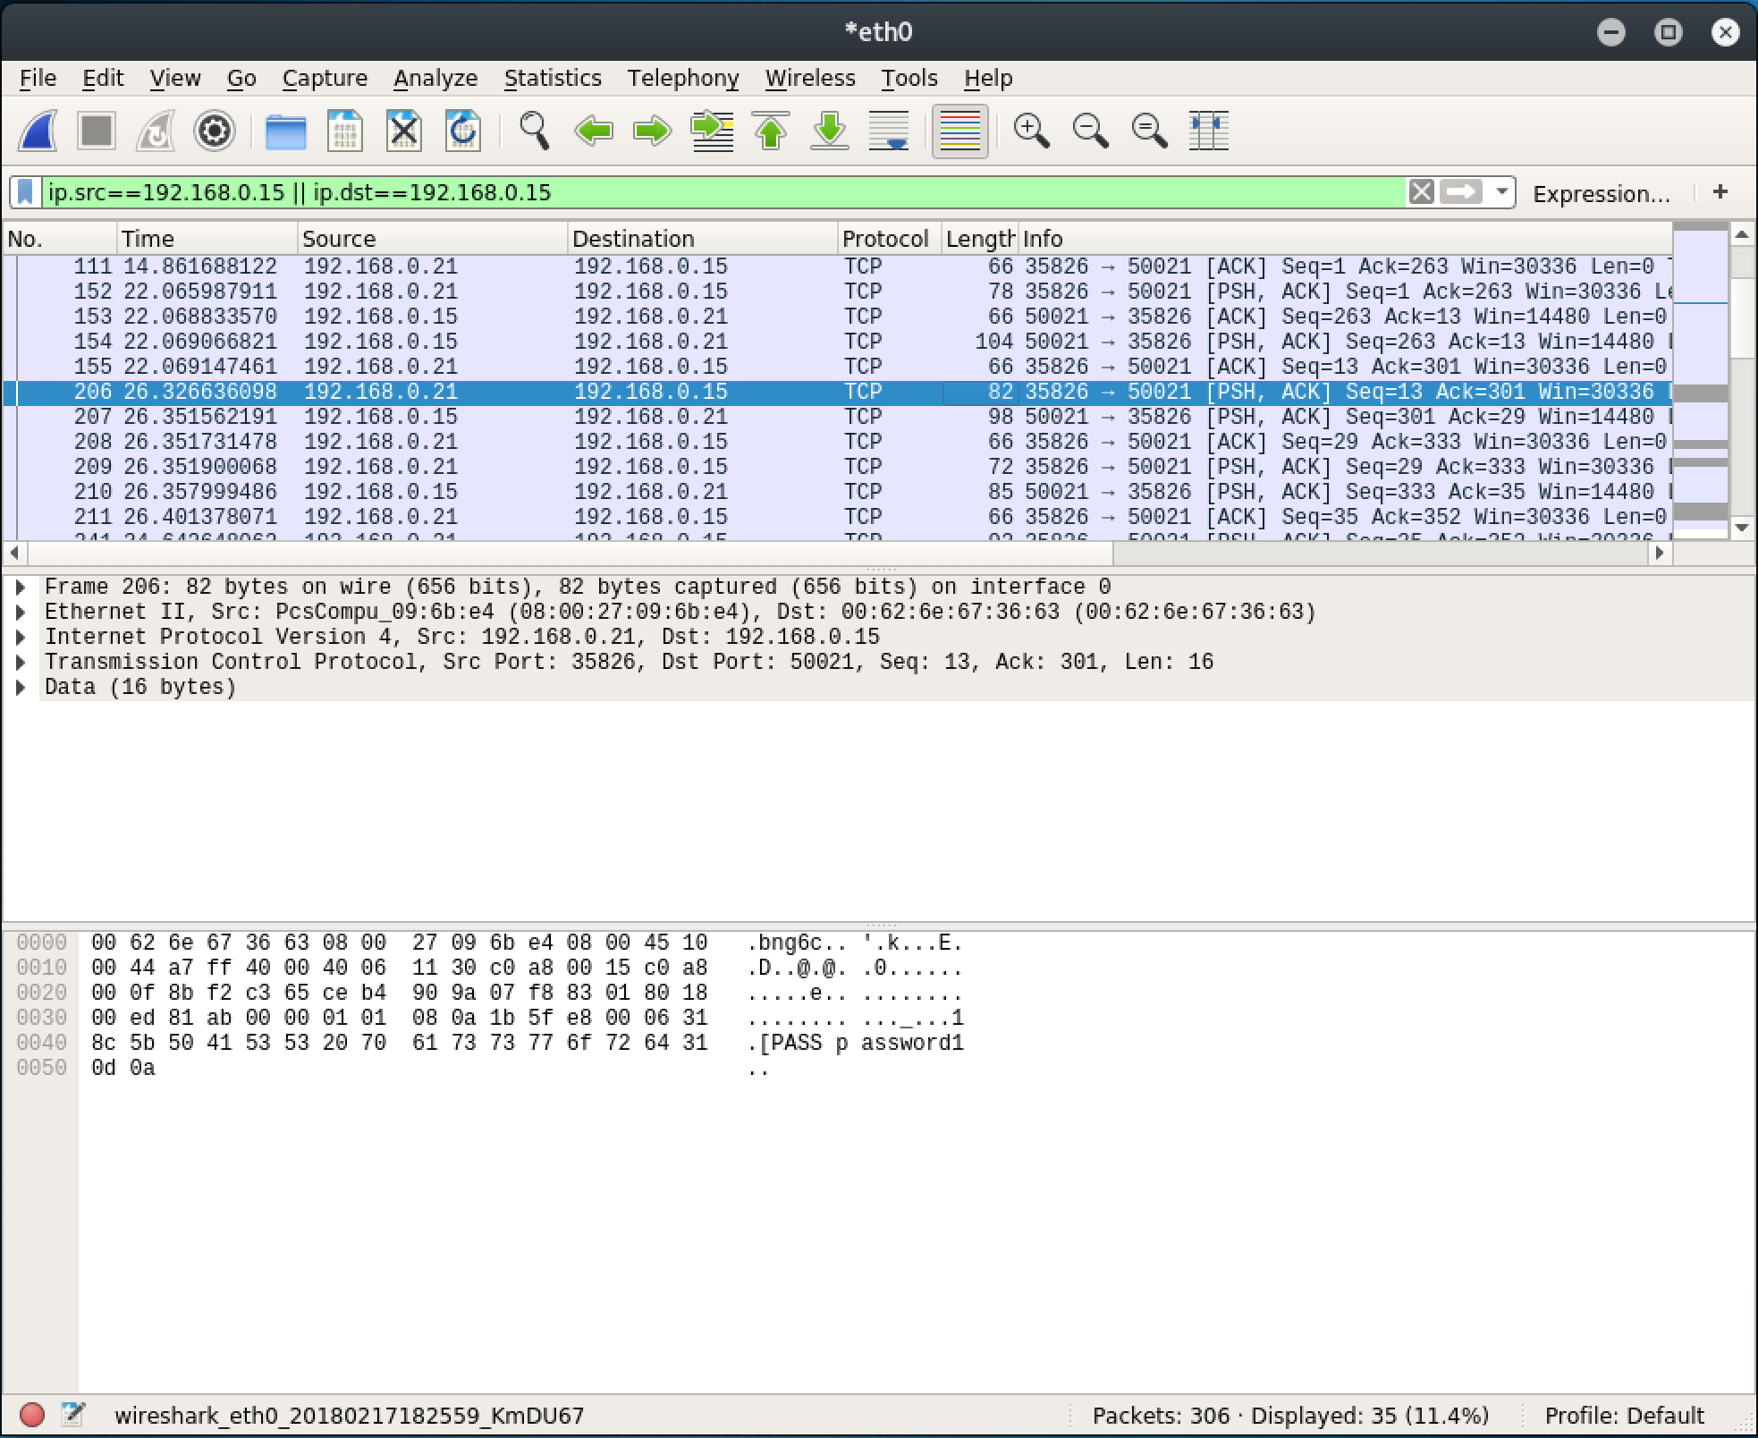

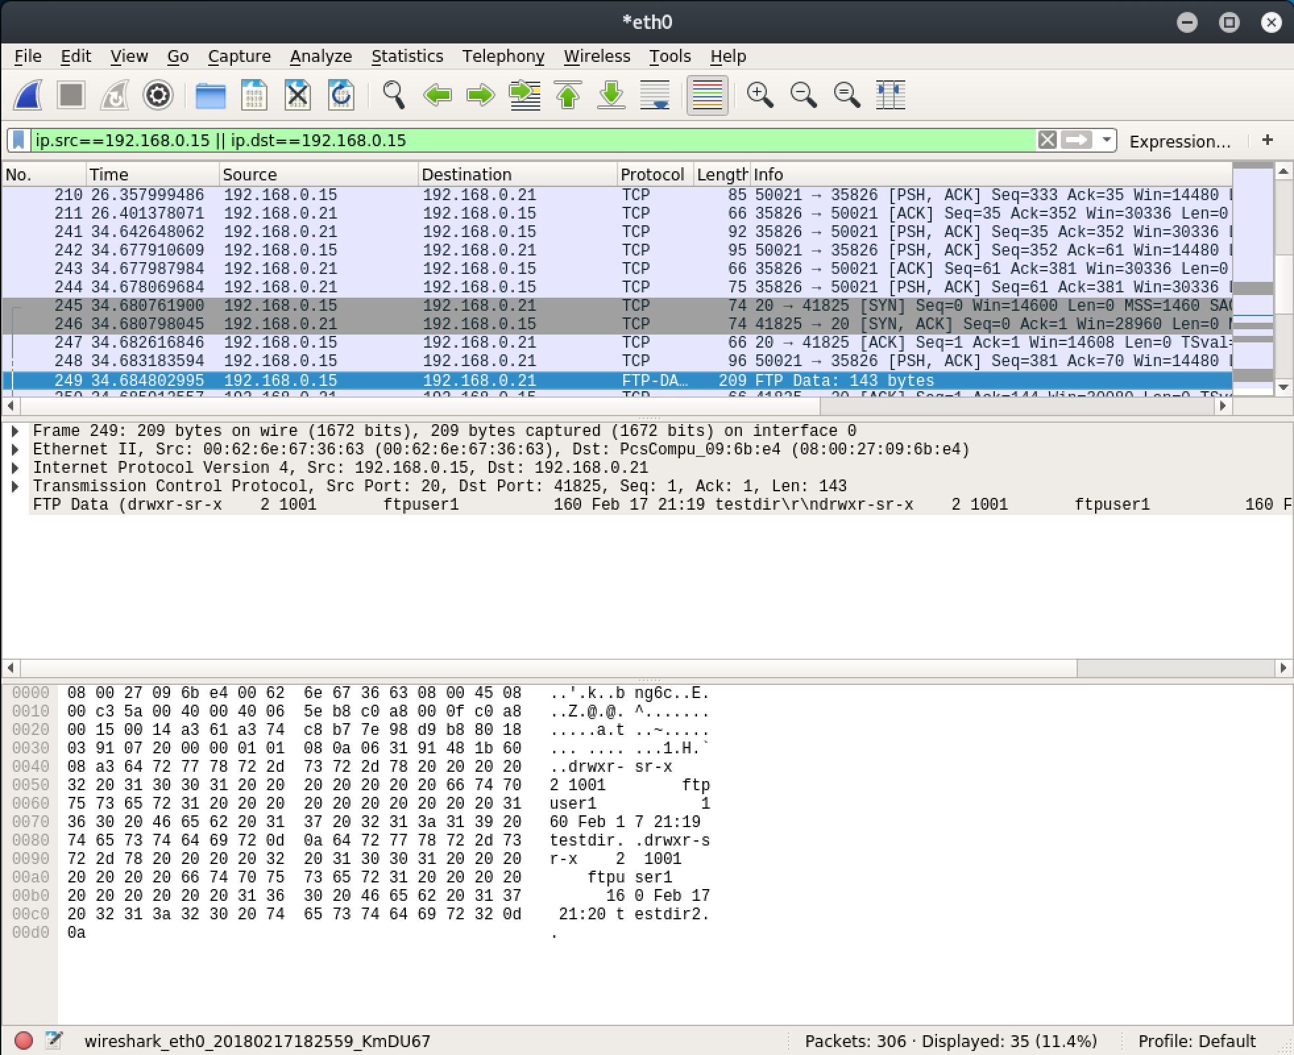

*iii. Exploit ONVIF information leak, launch brute-force attack against FTP*

An attacker who has gained access to a network, but is unaware of the devices on the network, could use an ONVIF application to exploit the information leak from part VII of the Discovered Vulnerabilities section to learn the manufacturer, model, and firmware versions of the camera. In addition to being able to perform both of the aforementioned attacks, this information can be used by the attacker to launch a brute-force attack against the FTP server. The lack of restrictions on login attempts described in vulnerability IV allows this attack. After discerning a valid set of credentials, the attacker can gain a foothold on the device.

**Conclusion**

This research project successfully uncovered a myriad of vulnerabilities in a variety of Foscam IP cameras, ranging from inadvertent leaking of sensitive device information to severe bugs that can allow an attacker to acquire full control of a device. The devices that were tested share the majority of these vulnerabilities, since they exist in the generic software and applications loaded onto the devices. The privacy and security implications of these findings should concern not only cybersecurity researchers and professionals, but consumers as well. By exploiting these vulnerabilities, attackers can view the live video feed of cameras owned by individuals and organizations, can infect these devices with malware to add them to a botnet, or can compromise them to pivot to other devices on the network. This research serves as a warning to tread carefully in the Internet of Things during its infancy and be aware of potential security issues, especially in devices of a sensitive nature.

*Dr. William Harrison, whose advice and support made this research possible, deserves special recognition for his contributions to this project.

**References**

1. “Inside the Infamous Mirai IoT Botnet: A Retrospective Analysis.” CloudFlare, 14 Dec. 2017, blog.cloudflare.com/inside-mirai-the-infamous-iot-botnet-a-retrospective-analysis/.
2. Nordrum, Amy. “Popular Internet of Things Forecast of 50 Billion Devices by 2020 Is Outdated.” IEEE Spectrum: Technology, Engineering, and Science News, IEEE, 18 Aug. 2016, spectrum.ieee.org/tech-talk/telecom/internet/popular-internet-of-things-forecast-of-50-billion-devices-by-2020-is-outdated.
3. Hsu, Chin-Lung, and Judy Chuan-Chuan Lin. “An Empirical Examination of Consumer Adoption of Internet of Things Services: Network Externalities and Concern for Information Privacy Perspectives.” Computers in Human Behavior, vol. 62, 2016, pp. 516–527., doi:10.1016/j.chb.2016.04.023.
4. “Vulnerabilities in Foscam IP Cameras.” F-Secure. http://images.news.f-secure.com/Web/FSecure/%7B43df9e0d-20a8-404a-86d0-70dcca00b6e5%7D_vulnerabilities-in-foscam-IP-cameras_report.pdf
5. “Company Profile.” Foscam About Us System, Foscam, www.foscam.com/company/about-us.html.
6. Akolomentsev, et al. “ONVIF Device Manager.” SourceForge, 2.2.250, 15 Nov. 2016, sourceforge.net/projects/onvifdm/.
7. “VirtualBox.” Oracle VM VirtualBox, 5.1.30, Oracle, 16 Oct. 2017, VirtualBox.org.
8. “Kali Linux.” Kali Linux, 4.13.0, Offensive Security, kali.org.
9. “Windows 10 Home.” Windows 10 - Microsoft Store, 1607, Microsoft, www.microsoft.com/en/us/store/b/windows.
10. Lyon, Gordon "Fyodor". “Nmap Security Scanner.” Nmap.org, 7.60, Insecure.com LLC, 1 Aug. 2017, Nmap.org.
11. Combs, Gerald, et al. “Wireshark.” Wireshark, 2.4.2, Riverbed, 10 Oct. 2017, Wireshark.org.
12. “VLC Media Player.” VideoLAN, 2.2.6 Umbrella, VideoLAN, videolan.org/vlc/index.html.